Help support
Semi-pro football benefiting NASO
vs 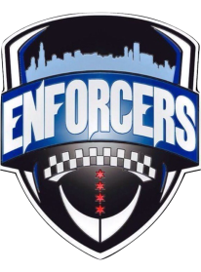
COLUMBUS MARAUDERS CHICAGO P.D. ENFORCERS
SATURDAY APRIL 7TH
4:00 pm
New Albany Eagle Stadium
FREE admission
Full contact, NCAA regulations “Football with a Purpose” played by first responders to raise money for their charities.
Bring your kids out to see;
Fire trucks, Police cars, Motorcycles, Horses, Franklin County Sheriff Dept. SWAT, Distracted Driving Simulator & CPD helicopter (weather permitting)
Concessions provided by the famous TORTILLA FOOD TRUCK!

